

CSA15 – CLOUD COMPUTING AND BIG DATA ANALYTICS

ASSIGNMENT 1 – CO1

Design, Analyse and Validate a Cloud-Based Solution for Migrating a Legacy University Management System
CO1: Apply cloud computing technologies including hardware–software evolution, virtualization, web services, and service models to develop cloud-based solutions.

Field | Details | Field | Details
Student Name | M.Balaji | Register Number | 192525059
Department / Section | AIML | Academic Year / Semester | 2025
Faculty Name | Latha.R | Nature of Assignment | Individual
Duration | 1 Week | Total Marks | 50
Submission Date | 31-10-2026 | Evaluation Date

MARK SHEET (Rubric-based evaluation)
Task | Title | Max | Awarded | Evidence / evaluation focus
1 | Introduce Cloud Computing | 3 |  | Definition; characteristics;  deployment models; scenario mapping
2 | Trace Evolution and Hardware Evolution | 3 |  | Timeline; hardware evolution; relevance to university
3 | Analyse Internet Software Evolution | 3 |  | Web/software evolution; SOA; APIs; scenario relevance
4 | Apply Server Virtualization | 5 |  | Hypervisor types; VM/container comparison; consolidation; limitations
5 | Apply Web Services | 4 |  | SOA and SOAP/REST; three university APIs; request/response examples
6 | Analyse IaaS, PaaS and SaaS | 5 |  | Responsibility layers; five-application mapping; comparison; providers
7 | Examine XaaS | 3 |  | Four or more variants; two justified choices; provider risks
8 | Design Cloud Solution | 5 |  | Labelled diagram;

 | Architecture |  |  | deployment/service models; scaling;  security; DR
9 | Hands-on Implementation and Documentation | 4 |  | Running VM/container; PaaS/SaaS; tests; actual screenshots
10 | Evaluate and Recommend Final Solution | 7 |  | Three-way comparison; 3-year costs; risks; phased roadmap
11 | Day-4 Design Challenge | 8 |  | Impact; evaluation; adaptation; evidence-based defence
 | TOTAL | 50 |  | Percentage :

EVIDENCE VERIFICATION CHECKLIST

Tasks | Evidence expected | Status (✓  / P / ✗ ) | Evaluator note
1–3 | Conceptual explanations, comparisons and relevant illustrations | ✓ | Explanations and relevant scenario mapping documented
4 | Virtualization calculations with  stated assumptions and peak-load caution | ✓ | Calculations present; practical capacity validation  recommended
5–7 | API examples, service responsibility table and justified XaaS choices | ✓ | Required conceptual evidence documented
8 | Labelled architecture diagram,  caption below figure and component justification | ✓ | Architecture documented;  sizing assumptions need testing
9 | Actual code, environment details, execution logs, API outputs and screenshots | P | Procedures provided; actual execution evidence not  established
10 | Cost assumptions, 3-year totals, risk controls and migration roadmap | ✓ | Estimates and rationale documented
11 | Day-4 changes, 10× load strategy, 99.9% target and 40-college isolation | ✓ | Design analysis documented; practical validation pending

IMPLEMENTATION EVIDENCE CHAIN

Evidence item | Status | Observation
Source code | ✓ | Flask REST API and Dockerfile provided in the proposed implementation
Virtualization | P | Docker container configuration documented; running-container evidence required
PaaS or SaaS | P | Managed web-service deployment procedure described; live deployment not verified
Functional test | P | Expected HTTP 200 response and JSON output documented; actual output required

Failure case | P | HTTP 404 test case documented; actual execution record required
Screenshots | P | Screenshot requirements identified; authentic screenshots need verification
Reproducibility | ✓ | Build commands, run commands, endpoints and expected results specified

OVERALL REMARKS

Student Signature | Faculty Signature | Program Director

MANDATORY SUBMISSION EVIDENCE CHECK
✓ = Present in documented answer; P = Partly present; ✗ = Missing / not satisfied

Task | Evidence expected | Status | Evaluator note
1 | Cloud definition, characteristics, deployment models and scenario mapping | ✓ | All conceptual requirements covered
2 | Evolution timeline, hardware  development and university relevance | ✓ | Well explained with relevant examples
3 | Internet software evolution, SOA and APIs | ✓ | Clear explanation and scenario relevance
4 | Hypervisors, VM/container  comparison and consolidation calculations | ✓ | Calculations included; peak-load limitations discussed
5 | SOAP/REST comparison and three university APIs | ✓ | API methods and request/response examples documented
6 | IaaS/PaaS/SaaS responsibility layers and application mapping | ✓ | All five applications categorized with justification
7 | XaaS variants and two justified selections | ✓ | Six variants explained; DBaaS and DRaaS recommended
8 | Labelled architecture, scaling, security and disaster recovery | ✓ | Design and component justifications documented
9 | Working container, PaaS/SaaS deployment, actual tests and screenshots | P | Code and procedures provided; actual  execution evidence requires verification
10 | Three-year cost comparison, risks and migration roadmap | ✓ | Cost assumptions, calculations and recommendations included
11 | Impact analysis, 10× load, 99.9% availability and tenant isolation | ✓ | Changed requirements evaluated; load-test evidence recommended

IMPLEMENTATION EVIDENCE CHAIN

Evidence item | Status | Observation
Source code | ✓ | Python Flask REST API and Dockerfile documented
Virtualization | P | Docker build and run procedures provided; execution screenshot required
PaaS or SaaS | P | Cloud deployment steps described; actual deployment confirmation required
Functional test | P | HTTP 200 and expected JSON response documented; actual

 |  | test output required
Failure case | P | HTTP 404 test case included; execution evidence required
Screenshots | P | Required screenshots identified but authenticity and completeness not verified
Reproducibility | ✓ | Installation, configuration, commands and testing steps documented
Interpretation | ✓ | Technical outcomes and implementation limitations explained
Code and report consistency | ✓ | Proposed API, Docker configuration and testing procedure are aligned

SUBMISSION CHECKLIST (Not Separately Marked)

Requirement | Status
All 11 tasks answered | ☒ Yes ☐ Partly ☐ No
Cloud concepts and comparisons explained | ☒ Yes ☐ Partly ☐ No
Virtualization calculations included | ☒ Yes ☐ Partly ☐ No
API examples and service models explained | ☒ Yes ☐ Partly ☐ No
Cloud architecture diagram included | ☒ Yes ☐ Partly ☐ No
Implementation and testing evidence provided | - Yes ☒ Partly ☐ No
Three-year cost analysis and roadmap included | ☒ Yes ☐ Partly ☐ No
Day-4 design challenge completed | ☒ Yes ☐ Partly ☐ No
Figures and screenshots included | - Yes ☒ Partly ☐ No
Table and figure numbering correct | - Yes ☒ Partly ☐ No
Viva recommended | ☒ Yes ☐ No

CSA15 – Cloud Computing and Big Data Analytics

ASSIGNMENT 1
CO1: Apply cloud computing technologies including hardware–software evolution, virtualization, web services, and service models to develop cloud-based solutions.

Assignment Title: Design, Analyse and Validate a Cloud-Based Solution for Migrating a Legacy University Management System (Total Marks – 50)

Duration: 1 week

Scenario – Smart Campus Cloud Migration
A multi-campus university currently runs its Student Information System, Learning Management System, Library System, Exam Portal and Email on ageing physical servers in a single on-premise data centre. Each application has its own dedicated server, which stays idle for most of the year but fails to cope during admissions, result publication and online-exam weeks.
The university's current environment is:
- 12 physical servers, average CPU utilisation of about 15%, with peaks above 95% during admissions and exams
- Approximately 25,000 students and 2,000 staff across 4 campuses
- Applications built as large monolithic programs, with no public interfaces for mobile apps or partner colleges
- High capital expenditure, slow procurement (6–8 weeks per server) and no disaster recovery site
As a cloud consultant, you must study how computing evolved to the cloud model, and then design a cloud-based solution that uses virtualization, web services and an appropriate mix of service models (IaaS, PaaS, SaaS and XaaS) for the university. All recommendations must be justified in terms of cost, scalability, availability and manageability.

Design Challenge:
On Day 4, the university announces that it will launch a mobile app and open student-record and fee-payment services to 40 affiliated colleges. Expected load is 10 times the current peak, with a requirement of 99.9% availability and a limited operating budget. Re-evaluate your original design and decide whether it should be retained, modified or redesigned.

TASK 1 – Introduce Cloud Computing and Map It to the Scenario (3 Marks)

Design and Propose cloud computing model for the context of the university's problems.
- Definition of cloud computing and the five essential characteristics (on-demand self-service, broad network access, resource pooling, rapid elasticity, measured service)
- Deployment models (public, private, hybrid, community) and which one suits the university
- Three problems of the current on-premise setup and how each cloud characteristic addresses them
- Benefits and limitations of cloud adoption for the university

Evidence Expected
A clear explanation of cloud characteristics and deployment models, mapped to the university's actual problems.

TASK 2 – Trace the Evolution and Hardware Evolution (3 Marks)
Trace how computing infrastructure evolved to make cloud computing possible.
- A timeline from mainframes, minicomputers and PCs, to client–server, clusters, grid computing, utility computing and cloud
- Hardware evolution: multi-core processors, commodity servers, high-capacity storage, high-speed networking and data centres
- How each stage solved a limitation of the previous one
- Which stage the university's current system corresponds to, with reasons

Evidence Expected
A labelled timeline or diagram, with a justified explanation of how hardware advances enabled the cloud.

TASK 3 – Analyse Internet Software Evolution (3 Marks)
Explain how internet software evolved and why it supports cloud services.
- Evolution from static web pages to dynamic web, Web 2.0, SOA, mashups and cloud-hosted applications
- Role of browsers, HTTP, AJAX and APIs in delivering software over the internet
- Comparison between desktop software, client–server software and web-delivered software
- How this evolution affects the design of the university's applications

Evidence Expected
A comparative explanation of software evolution stages, linked to the university's application design.

TASK 4 – Apply Server Virtualization (5 Marks)
Apply server virtualization to consolidate the university's 12 physical servers.
- Explain how a hypervisor works, and distinguish Type-1 and Type-2 hypervisors, with examples
- Compare full virtualization, para-virtualization, OS-level virtualization (containers) and hardware-assisted virtualization
- Propose which applications should run as virtual machines and which as containers, with reasons
- Calculate the consolidation: with an average utilisation of 15% per server and a target host utilisation of 70%, estimate how many physical hosts are needed (show your assumptions and working)
- Discuss live migration, snapshots and resource over-commitment as benefits, and the risks of virtualization (noisy neighbour, hypervisor failure, security isolation)

Show your calculation. A final number without working will not receive full credit.

Evidence Expected
A justified virtualization plan with a worked consolidation calculation and discussion of benefits and risks.

TASK 5 – Apply Web Services (4 Marks)
Analyse web services to expose the university's functions to other systems.
- Overview of web services and their role in cloud and SOA
- Compare SOAP, WSDL, UDDI and RESTful services (HTTP methods, JSON/XML)
- Identify at least three university functions to expose as web services (for example, result lookup, fee payment, library search) and define the endpoint, method and sample request/response for each
- Justify whether SOAP or REST is more suitable for each function

Evidence Expected

A defined set of web services with sample request/response formats and a justified choice of SOAP or REST

TASK 6 – Analyse the Service Models: IaaS, PaaS and SaaS (5 Marks)
Analyse which service model fits each university application.
- Define IaaS, PaaS and SaaS, and show who manages which layer (hardware to application) in each model
- Categorise the five university applications (SIS, LMS, Library, Exam Portal, Email) into IaaS, PaaS or SaaS, with reasons
- Compare the models on control, cost, scalability, maintenance effort and vendor lock-in
- Give one real provider example for each model
Present your categorisation in a table, but explain the reasoning behind each
decision. A table alone is not sufficient.

Evidence Expected
A reasoned mapping of applications to service models, supported by a layer-wise responsibility comparison.

TASK 7 – Examine XaaS (3 Marks)
Examine the broader XaaS (Anything-as-a-Service) concept for the university.
- Explain XaaS and describe at least four variants (for example DaaS, BaaS/MBaaS, FaaS, DBaaS, Security-as-a-Service, Disaster-Recovery-as-a-Service)
- Select two XaaS offerings that would benefit the university, and justify them
- Discuss the risks of over-reliance on multiple 'as-a-Service' providers

Evidence Expected
An analysis of XaaS variants, with justified selection of two offerings for the university.

TASK 8 – Design the Cloud Solution Architecture (5 Marks)
Bloom's Level: Level 6 – Create | Action verbs: Design, Construct, Propose
Create a complete cloud architecture for the university by combining virtualization, web services and service models.
- An architecture diagram showing users, load balancer, web/application tier, database tier, storage, API layer and DR region

- The deployment model and the service model chosen for each component
- How elasticity (auto-scaling) will handle admissions and exam peaks
- Basic security and availability measures (access control, encryption, backup, multi-zone deployment)

Evidence Expected
A labelled architecture diagram with written justification for each component and design decision.

TASK 9 – Hands-on Implementation and Documentation (4 Marks) Implement a small proof-of-concept of your design using a free-tier cloud account or a local virtualization tool.
- Create a virtual machine or container (using AWS/Azure/GCP free tier, VirtualBox, or Docker) and host a simple web page or REST API for one university function
- Deploy a SaaS or PaaS component (for example a cloud-hosted database, a serverless function or a static site)
- Test the web service with a client (browser, Postman or curl) and record the output
- Provide screenshots, configuration steps and any issues faced

Evidence Expected
Annotated screenshots and clear, reproducible steps showing that the proof-of-concept works.

TASK 10 – Evaluate and Recommend the Final Solution (7 Marks)
Evaluate your design and recommend the final cloud solution for the university.
- Compare on-premise, IaaS-based and PaaS/SaaS-based options on cost (CapEx vs OpEx), scalability, availability, security and effort
- Estimate a simple 3-year cost comparison using stated assumptions
- Identify the main risks (vendor lock-in, data privacy, downtime, skills gap) and give mitigation steps
- Provide your final recommendation and a short migration roadmap (which application moves first, and why)

Your recommendation must be supported by the analysis in the previous tasks. Choosing a popular cloud provider without justification is not sufficient.

Evidence Expected
A technically justified recommendation, supported by a cost comparison, risk analysis and migration roadmap.

DAY-4 DESIGN CHALLENGE

TASK 11 – Re-evaluate and Adapt the Design (8 Marks)

Changed Requirement
The university will now launch a mobile app and open student-record and fee-payment services to 40 affiliated colleges. Expected load is 10 times the current peak, availability must be 99.9%, and the operating budget is limited.
Re-evaluate your original design in response to these changed conditions. You may:
RETAIN → MODIFY → or REDESIGN
your original solution.

Impact Analysis – 2 Marks
Discuss:
- What has changed from the original problem
- Which original assumptions (load, users, availability, cost) are affected
- Why the web services and APIs now become critical
- How multi-tenant access by 40 colleges affects security and isolation
Evidence Expected: A clear analysis of how the changed requirements affect the original cloud design.

Evaluation of the Original Design – 2 Marks
Discuss:
- Whether the chosen service models and virtualization plan can handle a 10x load
- Whether auto-scaling and the single-region deployment are sufficient for 99.9% availability (about 8.76 hours of downtime allowed per year)
- Whether cost remains acceptable under the new load
- Whether another service model or XaaS offering would give better overall results
Evidence Expected: A technically supported evaluation of the original design under the new conditions.

Adaptation or Redesign – 2 Marks
Discuss:
- Decide whether to retain, modify or redesign the solution
- Describe the revised architecture (for example API gateway, container orchestration, serverless components, multi-zone deployment or a hybrid model)
- Explain what changed in the service model mix and in the virtualization approach
- If you retain the original design, give sufficient technical justification for why no change is required
Evidence Expected: An appropriate design response to the changed requirement, with clear technical reasoning.

Evidence-Based Defence – 2 Marks
Discuss:
- Capacity and availability calculations
- Cost comparison between the original and the revised design
- Security and multi-tenancy considerations
- Trade-offs such as vendor lock-in, complexity and migration effort
Evidence Expected: A well-supported final decision that follows logically from the analysis.

MARK DISTRIBUTION

Task | Title | Bloom's Level | Marks
Task 1 | Cloud Computing – Introduction & Characteristics | L2 – Understand | 3
Task 2 | Evolution & Hardware Evolution | L2 – Understand | 3
Task 3 | Internet Software Evolution | L2 – Understand | 3
Task 4 | Server Virtualization | L3 – Apply | 5
Task 5 | Web Services | L3 – Apply | 4
Task 6 | Service Models: IaaS, PaaS, SaaS | L4 – Analyze | 5
Task 7 | XaaS | L4 – Analyze | 3
Task 8 | Design the Cloud Solution Architecture | L6 – Create | 5
Task 9 | Hands-on Implementation & Documentation | L3 – Apply | 4
Task 10 | Evaluate & Recommend the Final Solution | L5 – Evaluate | 7
 | Subtotal

Task 11 | Day-4 Design Challenge | L4 / L5 / L6 | 8
 | TOTAL |  | 50

TASK 1 – Introduce Cloud Computing and Map It to the Scenario
1. Introduction to Cloud Computing
Cloud computing is a technology that provides computing resources such as servers, storage, databases, networking and software through the internet. It allows universities to access IT resources whenever required without purchasing and maintaining expensive physical infrastructure.
Proposed Model: SmartCampus Hybrid Cloud (SHC)
The SmartCampus Hybrid Cloud model combines private and public cloud services to improve university operations, reduce infrastructure costs and provide reliable access to academic resources.
2. Five Essential Characteristics of Cloud Computing
Characteristic | Explanation | Application in University
On-Demand Self-Service | Users can access resources whenever needed without manual assistance. | Students can access learning platforms and download study materials independently.
Broad Network Access | Services are accessible through different internet-connected devices. | Students and faculty can access university portals using laptops, tablets and smartphones.
Resource Pooling | Computing resources are shared among multiple users. | Storage and processing resources can be shared across departments.
Rapid Elasticity | Resources can automatically increase or decrease according to demand. | During examination results and online admissions, server capacity can increase automatically.
Measured Service | Resource usage is monitored and charged according to consumption. | The university can monitor storage, bandwidth and computing costs.
3. Cloud Deployment Models
Deployment Model | Description | University Application
Public Cloud | Cloud services are provided by third-party providers over the internet. | Hosting websites and public learning resources.
Private Cloud | Cloud infrastructure is dedicated to a single organization. | Storing confidential student records and examination data.
Hybrid Cloud | Combines private and public cloud environments. | Managing confidential records privately while using public cloud resources for academic services.
Community Cloud | Infrastructure is shared by organizations with similar requirements. | Multiple universities sharing research and academic resources.
Recommended Model: Hybrid Cloud
A hybrid cloud is the most suitable choice because universities handle both confidential information and large amounts of general academic data.
4. Three Problems in the Existing On-Premise Setup and Cloud-Based Solutions
Existing Problem | Cloud Characteristic | Proposed Solution
Limited server capacity during admissions and examinations. | Rapid Elasticity | Automatically increases computing capacity during peak periods.
Students cannot access resources easily outside the campus. | Broad Network Access | Provides 24/7 access to academic resources from anywhere.
High maintenance costs and inefficient resource usage. | Resource Pooling and Measured Service | Shares computing resources and monitors usage to reduce unnecessary expenses.
5. Benefits of Cloud Adoption
- Cost Reduction: Reduces investment in physical servers and maintenance.
- Easy Accessibility: Students and faculty can access academic services from anywhere.
- Scalability: Resources can expand during peak academic activities.
- Data Backup: Important academic information can be backed up in cloud storage.
- Collaboration: Faculty and students can share academic materials easily.
6. Limitations of Cloud Adoption
- Internet Dependency: Cloud services require a reliable internet connection.
- Security Risks: Confidential student information must be protected.
- Service Downtime: Cloud provider failures may temporarily interrupt services.
- Vendor Lock-in: Changing from one cloud provider to another can be difficult.
- Migration Cost: Initial migration and staff training may require investment.
7. Innovative Proposal – SmartCampus Hybrid Cloud
The proposed SmartCampus Hybrid Cloud introduces an intelligent resource management approach.
Unique Features:
- Predictive Resource Scaling: Predicts server requirements before examination and admission periods.
- Smart Storage Allocation: Automatically allocates storage based on departmental requirements.
- Secure Academic Vault: Keeps examination records and confidential student information in a private cloud.
- Campus Anywhere Access: Allows students and faculty to access academic services remotely.
Proposed System Flow Diagram:
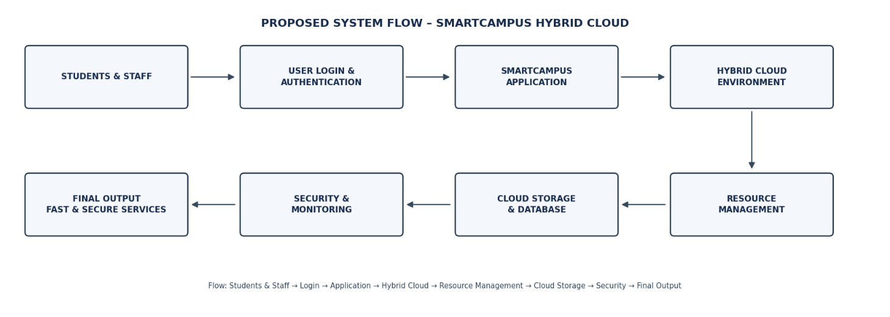
Conclusion:
The SmartCampus Hybrid Cloud model provides a secure, scalable and cost-effective solution to the university's existing infrastructure problems. By combining private and public cloud services, the university can improve academic accessibility, manage resources efficiently and support future digital transformation.
TASK 2 – Trace the Evolution and Hardware Evolution
1. Introduction
Cloud computing has evolved through several stages, starting from large mainframe computers to modern cloud-based systems. Each stage improved computing power, storage capacity, resource sharing, and accessibility.
The evolution of hardware, such as multi-core processors, high-capacity storage, powerful servers, and high-speed networks, made cloud computing possible.

2. Evolution of Computing
Stage | Description | Limitation Solved
Mainframe Computing | Large computers used by many users through terminals. | Reduced the need for separate computers for every user.
Minicomputers | Smaller and less expensive than mainframes. | Made computing accessible to smaller organizations.
Personal Computers (PCs) | Individual computers used by people. | Provided personal access to computing resources.
Client-Server Computing | Clients request services from a central server. | Enabled centralized data storage and resource sharing.
Cluster Computing | Multiple computers work together as one system. | Improved processing power and reliability.
Grid Computing | Computers in different locations share resources. | Enabled large-scale resource sharing.
Utility Computing | Computing resources are provided based on usage. | Reduced the need to purchase and maintain all resources.
Cloud Computing | Computing services are delivered through the internet. | Provides flexible, scalable, and on-demand resources.
3. Horizontal Diagram – Evolution of Computing
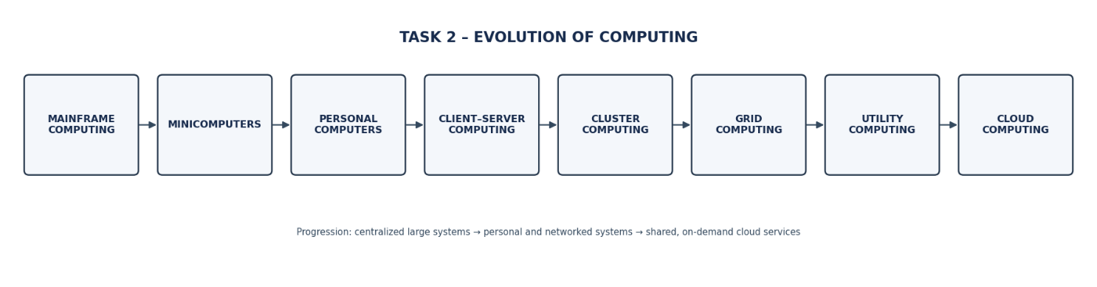
4. Evolution of Hardware
Hardware Development | Role in Cloud Computing
Multi-Core Processors | Perform multiple tasks simultaneously and improve processing speed.
Commodity Servers | Provide affordable computing power using standard hardware.
High-Capacity Storage | Store large amounts of data, files, and applications.
High-Speed Networking | Transfers data quickly between servers and users.
Data Centres | Provide centralized facilities containing servers, storage, networking, and cooling systems.

5. Horizontal Diagram – Hardware Evolution
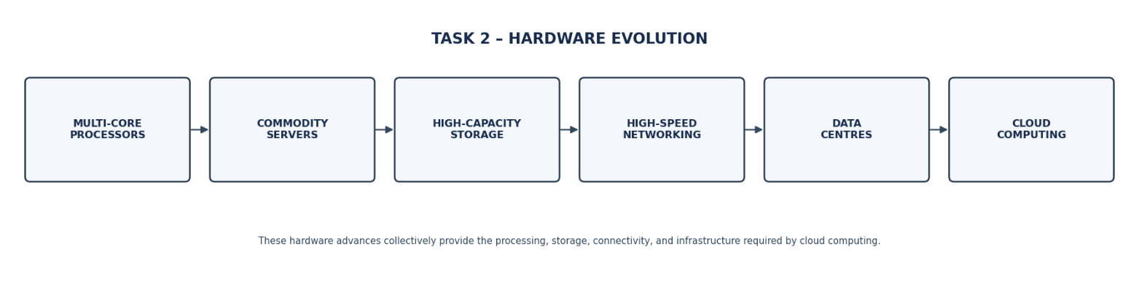
6. How Hardware Evolution Enabled Cloud Computing
- Faster Processing: Multi-core processors allow multiple applications to run simultaneously.
- Lower Cost: Commodity servers reduce the cost of building large computing systems.
- Large Storage: High-capacity storage supports huge amounts of university data.
- Faster Communication: High-speed networks enable users to access cloud services quickly.
- Centralized Management: Data centres manage servers, storage, security, and networking in one location.
7. Identify the University's Current Computing Stage
The university can be considered to be mainly using the Client-Server Computing Model with On-Premise Infrastructure, assuming its applications and data are hosted on servers within the campus.
Reasons:
- Student and staff information is maintained in centralized systems.
- Users access applications through computers connected to university servers.
- The university manages its own hardware and IT infrastructure.
- Storage and processing resources are limited by available campus hardware.
- Maintenance, upgrades, and backups require university IT support.
8. Innovative Idea – Predictive Cloud Infrastructure System (PCIS)
The university can introduce a Predictive Cloud Infrastructure System (PCIS) to improve its existing infrastructure.
- Predicts server usage during admissions, examinations, and result publication.
- Automatically increases computing resources when demand is high.
- Reduces resource usage during periods of low activity.
- Provides secure cloud storage for student records and academic documents.
- Reduces server downtime and improves application performance.
9. Benefits and Challenges
Benefits | Challenges
Improved processing speed | Initial migration cost
Better storage capacity | Internet dependency
Easy resource sharing | Data security concerns
Flexible resource usage | Need for technical knowledge
Reduced hardware maintenance | Dependence on cloud providers
10. Conclusion
The evolution from mainframe computers to cloud computing has improved computing performance, accessibility, and resource sharing. Hardware developments such as multi-core processors, powerful servers, high-capacity storage, and high-speed networking made cloud computing possible. By adopting a predictive cloud infrastructure system, the university can improve performance, reduce costs, and provide better digital services.

TASK 3: Analyse Internet Software Evolution
1. Introduction
Internet software has evolved from simple static web pages to advanced cloud-hosted applications. Earlier websites only displayed information, but modern applications allow users to interact, share data, and access services from anywhere.
Technologies such as browsers, HTTP, AJAX, and APIs help deliver software through the internet. This evolution supports cloud computing by making applications accessible, scalable, and easier to maintain.
2. Evolution of Internet Software
Evolution Stage | Description | Main Improvement
Static Web Pages | Websites display fixed information using HTML. | Provides basic online information.
Dynamic Web | Websites generate content based on user requests and database information. | Supports login forms and database operations.
Web 2.0 | Users can interact, upload, share, and update information. | Enables collaboration and user participation.
Service-Oriented Architecture (SOA) | Applications are divided into independent services that communicate with each other. | Supports service reuse and integration.
Mashups | Combines information or services from multiple sources using APIs. | Provides multiple services in one application.
Cloud-Hosted Applications | Applications run on cloud servers and are accessed through the internet. | Provides scalability, availability, and remote access.
3. Horizontal Flow Diagram – Evolution of Internet Software
Download the fixed horizontal diagram:
Task 3 – Internet Software Evolution Image
4. Role of Internet Technologies in Cloud Services
Technology | Role | University Application Example
Web Browser | Provides an interface to access web applications. | Students access the university portal using Chrome.
HTTP/HTTPS | Transfers requests and responses between browsers and servers. | Sends login and attendance requests securely using HTTPS.
AJAX | Updates parts of a webpage without reloading the entire page. | Displays attendance details instantly.
APIs | Allow different applications to communicate and exchange data. | Connects the student portal with payment and examination systems.
How These Technologies Work Together
- The user opens the university application through a web browser.
- The browser sends a request to the cloud server using HTTP/HTTPS.
- The server processes the request and retrieves the required data.
- AJAX updates the required information without refreshing the complete webpage.
- APIs connect different university services and exchange information.
- The requested result is displayed to the user.

5. Comparison of Software Types
Feature | Desktop Software | Client-Server Software | Web-Delivered Software
Installation | Installed on individual computers. | Client software may need installation. | Usually accessed through a browser.
Accessibility | Mainly available on the installed device. | Available through connected client systems. | Accessible from anywhere with internet access.
Data Storage | Usually stored locally. | Stored on a central server. | Stored on cloud servers or connected databases.
Maintenance | Updated on individual devices. | Server and client maintenance required. | Updates can be managed centrally.
Scalability | Limited by device resources. | Depends on server capacity. | Can scale cloud resources based on demand.
Example | MS Paint | Traditional university client-server system | Cloud-based student portal
6. Impact on University Application Design
The evolution of internet software changes how university applications are designed and maintained.
- Browser-Based Access: Students and staff can access applications without installing separate software.
- Centralized Database: Student records, attendance, fees, and examination details can be maintained centrally.
- Real-Time Updates: AJAX can display attendance, marks, and notifications without reloading the entire page.
- System Integration: APIs connect the student portal, payment gateway, library, and examination systems.
- Cloud Scalability: Cloud resources can increase during admissions and examination-result periods.
- Improved Security: HTTPS, authentication, and access control help protect university information.
7. Innovative Idea – SmartCampus Unified Web Portal
The university can implement a SmartCampus Unified Web Portal using cloud-hosted applications and API integration.
- Provides a single portal for students, faculty, and administrators.
- Integrates attendance, fees, examinations, library, and learning materials.
- Uses AJAX for instant updates and notifications.
- Uses APIs to connect different university departments.
- Stores academic information securely using cloud databases.
- Supports access through laptops, tablets, and smartphones.
8. Benefits and Challenges
Benefits | Challenges
Access from anywhere | Requires internet connectivity
Easy software updates | Security threats
Real-time information | API integration complexity
Centralized data management | Data privacy concerns
Supports more users | Cloud service dependency

9. Conclusion
Internet software evolved from static web pages to dynamic, interactive, and cloud-hosted applications. Technologies such as browsers, HTTP, AJAX, and APIs make online software communication and service integration possible. By adopting a SmartCampus Unified Web Portal, the university can provide accessible, integrated, and efficient digital services to students and staff.
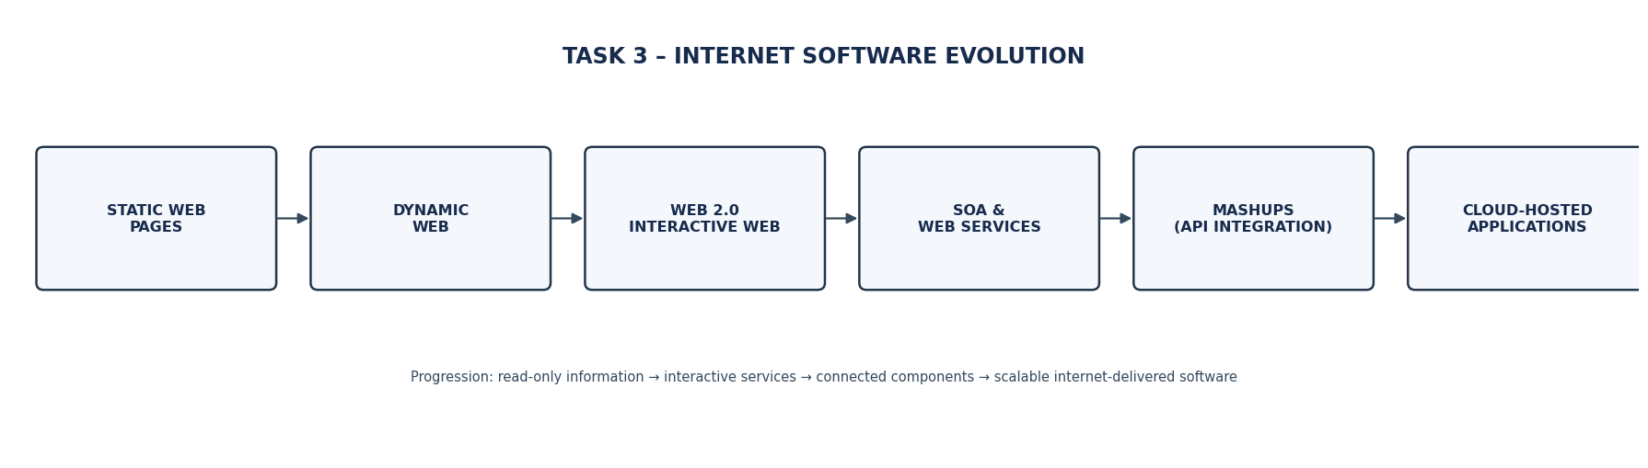

TASK 4 – Apply Server Virtualization
1. Introduction
Server virtualization is a technology that allows multiple virtual servers to run on a single physical server. It helps universities reduce hardware costs, improve resource utilisation, save electricity and manage servers efficiently.
In this university, there are 12 physical servers. By applying server virtualization, these servers can be consolidated into a smaller number of powerful physical hosts.
2. Working of a Hypervisor
A hypervisor is software or firmware that creates and manages Virtual Machines (VMs) on a physical server.
How it works:
- The hypervisor runs on the physical server.
- It divides hardware resources such as CPU, RAM and storage.
- It creates multiple Virtual Machines.
- Each VM runs its own operating system and applications.
- The hypervisor manages resource allocation between VMs.
Types of Hypervisors
Type | Explanation | Examples
Type-1 (Bare Metal) | Runs directly on physical hardware. It provides better performance and security. | VMware ESXi, Microsoft Hyper-V, Xen
Type-2 (Hosted) | Runs on top of an existing operating system. | Oracle VirtualBox, VMware Workstation
Recommendation: Type-1 hypervisor is suitable for the university because it provides better performance, scalability and resource management.
3. Comparison of Virtualization Techniques
Technique | Explanation | Example
Full Virtualization | Creates a complete virtual hardware environment for the guest OS. | VMware ESXi
Para-Virtualization | Guest OS is modified to communicate with the hypervisor for better performance. | Xen PV
OS-Level Virtualization | Multiple isolated containers share the same operating system kernel. | Docker, LXC
Hardware-Assisted Virtualization | Uses processor features such as Intel VT-x and AMD-V to improve virtualization performance. | Intel VT-x, AMD-V
Conclusion: Hardware-assisted virtualization is recommended for running multiple VMs efficiently, while containers are suitable for lightweight applications.
4. Applications Suitable for VMs and Containers
The university can use both Virtual Machines and Containers.
Applications | Virtualization Type | Reason
Student Management System | Virtual Machine | Requires a separate operating system and strong isolation.
University Database | Virtual Machine | Needs dedicated resources and data protection.
Library Management System | Container | Lightweight and easy to deploy.
University Website | Container | Supports quick deployment and scaling.
Online Examination System | Virtual Machine | Requires better isolation and security.
Attendance Application | Container | Requires fewer resources and easy maintenance.
Justification: VMs are suitable for applications requiring separate operating systems and strong isolation. Containers are suitable for lightweight applications that need fast deployment and scalability.
5. Server Consolidation Calculation
Given:
- Total physical servers = 12
- Average utilisation per server = 15%
- Target host utilisation = 70%
Step 1: Calculate total current utilisation
Total utilisation:
= Number of servers × Average utilisation
= 12 × 15%
= 180%
Step 2: Calculate the number of physical hosts required
Number of hosts:
= Total utilisation / Target host utilisation
= 180 / 70
= 2.57
Step 3: Round up the result
= 3 Physical Hosts
Final Result
Details | Value
Existing physical servers | 12
Average utilisation | 15%
Total utilisation | 180%
Target host utilisation | 70%
Required physical hosts | 3
Conclusion: By using server virtualization, the university can consolidate 12 physical servers into 3 physical hosts.
This reduces the physical server requirement by:
12 − 3 = 9 servers (75% reduction).
Assumption: All 12 servers have approximately equal capacity, and their combined CPU demand is used for this estimate. Actual sizing must also consider RAM, storage, network capacity and peak workloads. The calculation does not include additional failover capacity.
6. Benefits of Virtualization
1. Live Migration
- Moves a running VM from one physical host to another.
- Reduces downtime during maintenance.
- Improves workload management.
2. Snapshots
- Saves the current state of a Virtual Machine.
- Helps restore the VM after configuration errors.
- Useful before software updates.
3. Resource Over-Commitment
- Allows virtual machines to share physical resources.
- Improves hardware utilisation.
- Helps reduce hardware costs.
7. Risks of Virtualization
Risk | Explanation | Solution
Noisy Neighbour | One VM consumes excessive resources and affects other VMs. | Set CPU and memory limits.
Hypervisor Failure | If the hypervisor fails, multiple VMs may stop working. | Use backup hosts and high availability.
Security Isolation | Security attacks may affect other VMs if isolation is weak. | Apply security patches and access controls.
8. Proposed Virtualization Architecture
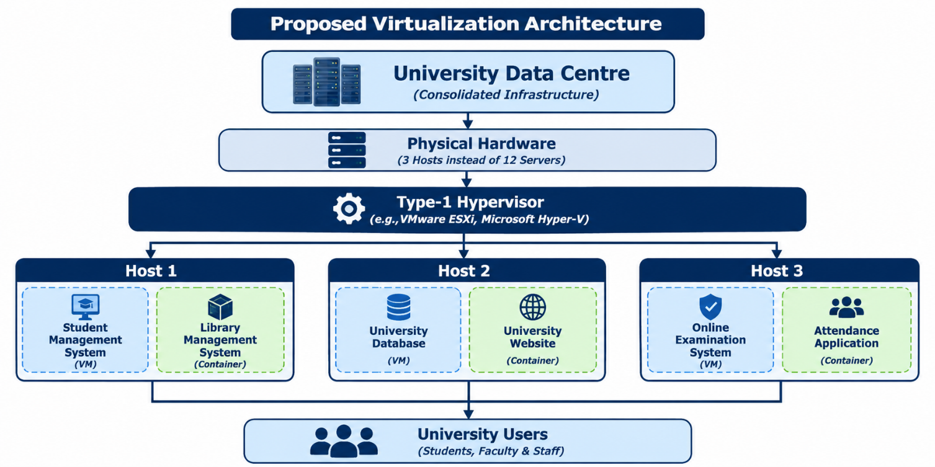
9. Conclusion
Server virtualization helps the university consolidate its 12 physical servers into 3 physical hosts based on the given utilisation assumptions. Using a Type-1 hypervisor, Virtual Machines and containers improves resource utilisation, reduces hardware costs and simplifies server management. Live migration, snapshots and resource over-commitment provide additional benefits, while proper security and backup mechanisms help manage virtualization risks.

TASK 5 – Apply Web Services
1. Overview of Web Services
Web services are software components that allow different applications to communicate and exchange data over a network using standard protocols.
In a university, web services help connect student management systems, examination systems, fee payment systems and library systems.
Role of Web Services in Cloud and SOA
- Cloud Computing: Allows applications to access services over the internet.
- Service-Oriented Architecture (SOA): Divides applications into independent services that communicate with each other.
- Reusability: The same service can be used by multiple applications.
- Integration: Connects different university systems easily.
- Scalability: Services can be updated and expanded independently.
2. Comparison of SOAP, WSDL, UDDI and RESTful Services
Technology | Description | Data Format / Protocol
SOAP | Protocol used to exchange structured messages between applications. | XML
WSDL | Describes web service operations, endpoints and message formats. | XML
UDDI | Registry used to publish and discover web services. | XML-based registry
REST | Architectural style used to access services through HTTP methods. | JSON or XML
HTTP Methods Used in REST
Method | Purpose | Example
GET | Retrieve information | View student results
POST | Submit new information | Make fee payment
PUT | Update existing information | Update student details
DELETE | Remove information | Delete a record
Example: REST uses HTTP methods and JSON to exchange data between the university website and its database.
3. University Functions Exposed as Web Services
The university can expose the following four functions as web services.
Service 1: Student Result Lookup
Purpose: Allows students to view their examination results online.
- Endpoint: /api/students/results
- HTTP Method: GET
- Format: JSON
- Service Type: REST
Sample Request:
GET /api/students/results/192525059
Sample Response:
{
"student_id": "192525059",
"name": "Balaji",
"subject": "Cloud Computing",
"marks": 85,
"result": "PASS"
}
Justification: REST is suitable because students need quick access to examination results. GET requests allow easy retrieval of data.
Service 2: Online Fee Payment
Purpose: Allows students to pay university fees through an online payment system.
- Endpoint: /services/fee-payment
- Method: POST
- Format: XML
- Service Type: SOAP
Sample Request:
<FeePayment>
<StudentID>192525059</StudentID>
<Amount>25000</Amount>
<PaymentMode>UPI</PaymentMode>
</FeePayment>
Sample Response:
<PaymentResponse>
<Status>Success</Status>
<TransactionID>TXN1025</TransactionID>
<Amount>25000</Amount>
</PaymentResponse>
Justification: SOAP is suitable for fee payment because it supports structured messages and enterprise security standards such as WS-Security. Payment systems also require reliable transaction handling.
Service 3: Library Book Search
Purpose: Allows students to search for books and check their availability.
- Endpoint: /api/library/books
- HTTP Method: GET
- Format: JSON
- Service Type: REST
Sample Request:
GET /api/library/books?name=Python
Sample Response:
{
"book_name": "Python Programming",
"author": "John Smith",
"availability": "Available",
"total_copies": 10
}
Justification: REST is suitable because it provides fast and simple access to library information using GET requests.
Service 4: Student Attendance
Purpose: Allows faculty members to submit and update student attendance.
- Endpoint: /api/attendance
- HTTP Method: POST
- Format: JSON
- Service Type: REST
Sample Request:
{
"student_id": "192525059",
"subject": "Cloud Computing",
"attendance": "Present"
}
Sample Response:
{
"status": "Success",
"message": "Attendance recorded"
}
Justification: REST is suitable because attendance data can be easily submitted and updated using HTTP methods and JSON.
4. SOAP vs REST – Final Comparison
Feature | SOAP | REST
Type | Protocol | Architectural style
Data Format | XML only | JSON, XML and others
Speed | Generally heavier | Generally lightweight
Security | Supports WS-Security | Uses HTTPS and other security mechanisms
Usage | Enterprise transactions | Web and mobile applications
Complexity | More complex | Simple and flexible
Recommended Approach
For the university:
- Student Result Lookup: REST
- Online Fee Payment: SOAP
- Library Book Search: REST
- Student Attendance: REST
REST is recommended for most university services because it is lightweight, flexible and easy to integrate. SOAP is recommended for fee payment when enterprise-level messaging and WS-Security requirements are needed.
5. Proposed Web Services Architecture
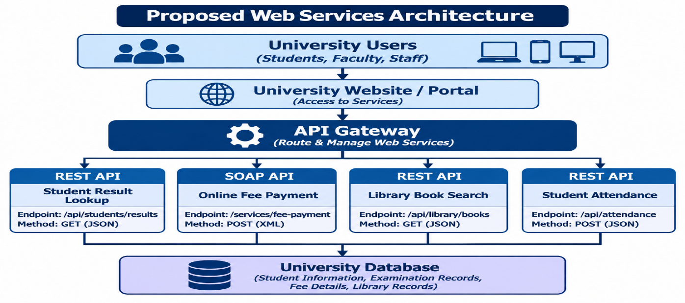
6. Conclusion
Web services help the university connect different applications and share information efficiently. REST and SOAP provide communication between systems, while WSDL describes services and UDDI helps discover them. By implementing result lookup, online fee payment, library search and attendance services, the university can improve accessibility, integration, security and overall efficiency.

TASK 6 – Analyse the Service Models: IaaS, PaaS and SaaS
1. Introduction
Cloud computing provides three major service models: Infrastructure as a Service (IaaS), Platform as a Service (PaaS) and Software as a Service (SaaS).
These models help universities manage applications, store data and provide online services without maintaining all IT infrastructure themselves.
Each model offers different levels of control, cost, scalability and maintenance.
2. Definition of IaaS, PaaS and SaaS
A. Infrastructure as a Service (IaaS)
- IaaS provides virtual machines, storage, networking and computing resources over the internet.
- The university manages the operating system, applications and data.
- It provides greater control over infrastructure.
Example: Amazon Web Services (AWS EC2).
B. Platform as a Service (PaaS)
- PaaS provides a platform to develop, test and deploy applications.
- The cloud provider manages hardware, operating systems and runtime environments.
- Developers focus on application development without managing servers.
Example: Google App Engine.
C. Software as a Service (SaaS)
- SaaS provides ready-to-use software applications through the internet.
- The cloud provider manages infrastructure, software and maintenance.
- Users can access applications through a web browser.
Example: Microsoft 365.
3. Layer-Wise Responsibility Comparison
The following table shows which layers are managed by the cloud provider and the university.
Layers | IaaS | PaaS | SaaS
Applications | University | University | Provider
Data | University | University | Provider manages platform; university controls its data
Runtime | University | Provider | Provider
Middleware | University | Provider | Provider
Operating System | University | Provider | Provider
Virtualization | Provider | Provider | Provider
Servers | Provider | Provider | Provider
Storage | Provider | Provider | Provider
Networking | Provider | Provider | Provider
Explanation:
- IaaS: The provider manages physical infrastructure, while the university manages the operating system and applications.
- PaaS: The provider manages infrastructure and the software platform, while the university develops and manages its applications.
- SaaS: The provider manages the complete application and underlying infrastructure. The university mainly manages user access, settings and its data.
4. Categorisation of Five University Applications
The university has five major applications: Student Information System (SIS), Learning Management System (LMS), Library Management System, Examination Portal and Email System.
The following table shows the suitable cloud service model for each application.
University Application | Service Model | Reason
Student Information System (SIS) | IaaS | Requires control over student records, databases and application configuration.
Learning Management System (LMS) | PaaS | Allows developers to customise and deploy learning applications easily.
Library Management System | SaaS | Ready-made library software reduces development and maintenance work.
Examination Portal | IaaS | Provides greater control over server configuration, security and examination workloads.
Email System | SaaS | Provides ready-to-use email services without managing email servers.
Explanation of Each Decision
1. Student Information System (IaaS)
The Student Information System stores student details, attendance, academic records and personal information. IaaS is suitable because the university needs control over its virtual servers, operating systems and databases.
2. Learning Management System (PaaS)
The Learning Management System manages online courses, assignments, study materials and student activities. PaaS is suitable because developers can build and customise learning applications without managing physical servers.
3. Library Management System (SaaS)
The Library Management System manages book details, borrowing, returning and availability. SaaS is suitable because the university can use ready-made library software without developing and maintaining its own application.
4. Examination Portal (IaaS)
The Examination Portal manages online examinations, question papers, student login and results. IaaS is suitable because the university needs greater control over security, server resources and examination infrastructure.
5. Email System (SaaS)
The university email system provides communication between students, faculty and staff. SaaS is suitable because services such as Microsoft 365 provide ready-to-use email facilities, storage and communication tools.
5. Comparison of IaaS, PaaS and SaaS
Factor | IaaS | PaaS | SaaS
Control | High | Medium | Low
Cost | Pay for infrastructure usage | Pay for platform usage | Subscription-based
Scalability | Flexible | Easily scalable | Provider-managed scaling
Maintenance | High | Medium | Low
Vendor Lock-in | Generally lower, but depends on architecture | Higher due to platform dependencies | Higher due to application and data migration
Explanation
1. Control: IaaS provides maximum control over servers and operating systems. PaaS provides control over applications, while SaaS offers limited technical control.
2. Cost: IaaS requires payment for computing resources. PaaS charges for platform usage, while SaaS generally uses subscription-based pricing.
3. Scalability: IaaS allows users to increase virtual resources. PaaS supports easy application scaling, while SaaS scaling is mainly managed by the provider.
4. Maintenance: IaaS requires more maintenance because the university manages operating systems and applications. PaaS reduces maintenance, while SaaS requires minimal technical maintenance.
5. Vendor Lock-in: Vendor lock-in means depending heavily on one cloud provider. PaaS and SaaS may create greater dependency because applications and data may rely on provider-specific services and formats.
6. Real-Time Cloud Provider Examples
Service Model | Provider | Example Service
IaaS | Amazon Web Services | Amazon EC2
PaaS | Google Cloud | Google App Engine
SaaS | Microsoft | Microsoft 365
7. Conclusion
IaaS, PaaS and SaaS provide different levels of cloud computing services to universities. IaaS is suitable for applications requiring greater infrastructure control, PaaS is useful for developing and customising applications, and SaaS is suitable for ready-to-use software.
By selecting the appropriate service model for SIS, LMS, Library, Examination Portal and Email, the university can reduce infrastructure costs, improve scalability and simplify IT management.
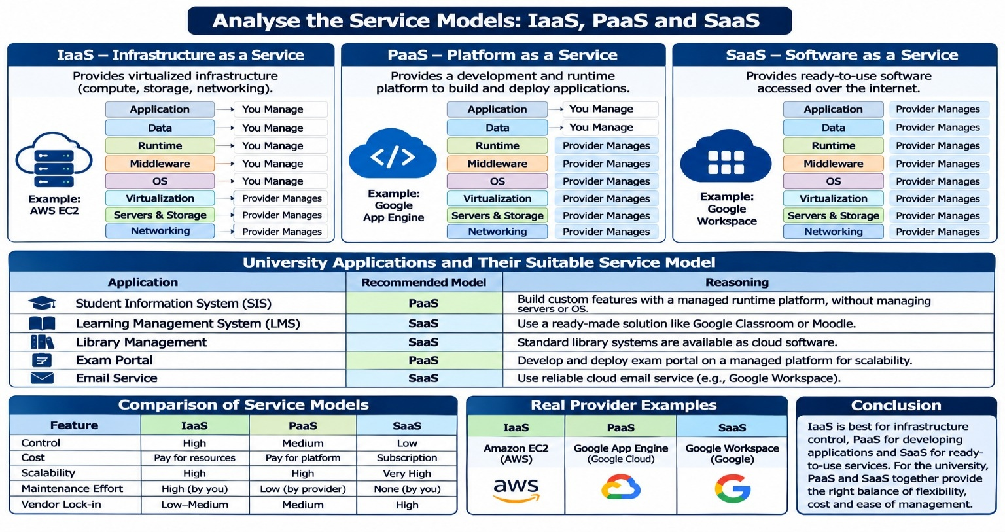

TASK 7 – Examine XaaS
1. Introduction to XaaS
XaaS stands for Anything as a Service. It is a cloud computing model in which different IT services are provided over the internet based on user requirements.
Instead of purchasing and maintaining hardware or software, universities can access services from cloud providers and pay according to usage.
2. Types of XaaS
XaaS Type | Full Form | Explanation
DaaS | Desktop as a Service | Provides virtual desktops to students and faculty through the internet.
BaaS | Backend as a Service | Provides backend services such as authentication and database connectivity.
FaaS | Function as a Service | Runs individual application functions without managing servers.
DBaaS | Database as a Service | Provides cloud-based databases without managing database servers.
Security as a Service | SECaaS | Provides cloud-based security, antivirus and threat monitoring.
DRaaS | Disaster Recovery as a Service | Provides backup and recovery services during system failures.
3. Two Recommended XaaS Offerings for the University
1. Database as a Service (DBaaS)
- Provides a cloud-based database to store student records, examination results and fee details.
- Reduces database maintenance work.
- Provides automatic backups and scalability.
- Helps university applications access data efficiently.
Justification: DBaaS is suitable because the university manages large amounts of student and academic information. It reduces database administration and improves availability.
2. Disaster Recovery as a Service (DRaaS)
- Provides backup and recovery facilities.
- Protects university data from hardware failures and cyberattacks.
- Helps restore applications during unexpected disasters.
- Reduces downtime and data loss.
Justification: DRaaS is important because university systems such as examination portals, student records and fee payment must remain available even during system failures.
4. Risks of Over-Reliance on Multiple XaaS Providers
Risk | Explanation | Solution
Vendor Lock-in | Depending on one provider makes migration difficult. | Use standard technologies and portable data formats.
Data Security | Data stored with multiple providers may face security threats. | Apply encryption and access controls.
Service Downtime | Provider failures may interrupt university services. | Maintain backup and recovery systems.
Integration Issues | Different providers may use different technologies. | Use standard APIs and integration tools.
Cost Increase | Multiple subscriptions may increase expenses. | Monitor usage and control cloud spending.
5. Conclusion
XaaS provides flexible and cost-effective IT services to universities. DBaaS and DRaaS are recommended because they improve database management, data protection and service availability. However, the university should carefully manage security, costs and vendor dependency

TASK 8 – Design the Cloud Solution Architecture
1. Introduction
Cloud architecture is the arrangement of cloud resources, applications, databases, storage and networking to provide services over the internet.
The proposed university cloud architecture combines virtualization, web services, APIs and cloud service models to provide reliable and scalable services.

2. Proposed Cloud Architecture Diagram
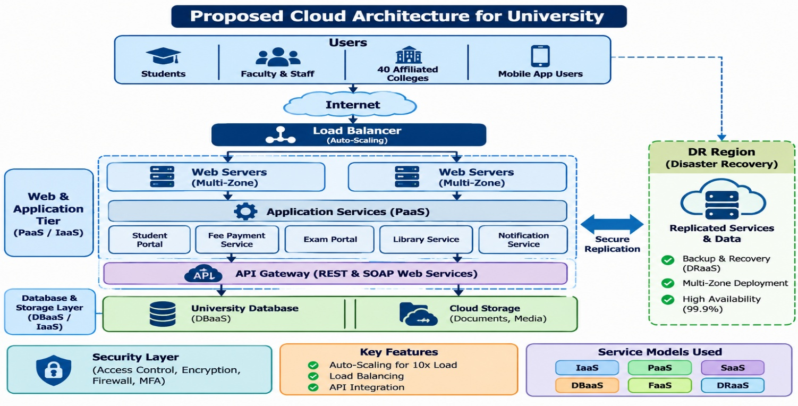
3. Components and Service Models
Component | Service Model | Purpose
Load Balancer | IaaS | Distributes user requests across servers.
Web Server | IaaS | Hosts the university website.
Application Tier | PaaS | Runs university applications.
API Gateway | PaaS | Manages communication between services.
Database | DBaaS | Stores student and academic information.
Cloud Storage | IaaS | Stores documents, certificates and files.
Backup and DR | DRaaS | Protects data and restores services.
4. Deployment Model
Hybrid Cloud Deployment Model
The university should adopt a hybrid cloud model.
- Private cloud can store sensitive student records and examination information.
- Public cloud can host the university website and student-facing applications.
- Both environments can communicate through secure APIs.
Reason: Hybrid cloud provides a balance between security, flexibility, scalability and cost.
5. Elasticity and Auto-Scaling
Elasticity means automatically increasing or decreasing cloud resources based on workload requirements.
The university experiences high traffic during:
- Student admissions.
- Examination registration.
- Online examinations.
- Result publication.
- Fee payment deadlines.
Auto-scaling process:
- The system monitors CPU, memory and incoming requests.
- When traffic increases, additional virtual machines or application instances are created.
- The load balancer distributes incoming requests.
- When traffic decreases, unnecessary instances are removed.
- This reduces cost and improves performance.
6. Security and Availability Measures
Security Measure | Explanation
Access Control | Only authorised users can access university services.
Encryption | Protects data during transmission and storage.
Regular Backup | Prevents permanent data loss.
Multi-Zone Deployment | Runs applications across multiple availability zones.
Firewall | Prevents unauthorised network access.
Authentication | Uses secure login and multi-factor authentication.
7. Conclusion
The proposed cloud architecture combines IaaS, PaaS, SaaS and web services to provide an efficient university management system. Hybrid cloud deployment, load balancing, auto-scaling, encryption and disaster recovery improve performance, security and availability.

TASK 9 – Hands-on Implementation and Documentation
1. Introduction
The purpose of this task is to implement a small proof-of-concept using a local virtualization tool or free-tier cloud platform.
For this implementation, we use Docker to create a container and host a simple university student result lookup REST API.
2. Tools Required
Tool | Purpose
Docker Desktop | Create and run containers.
Python | Develop the REST API.
Flask | Create web services.
Web Browser | Test the application.
Windows 11 | Operating environment.
3. Implementation Architecture
UNIVERSITY USER
|
WEB BROWSER
|
HTTP REQUEST
|
DOCKER CONTAINER
|
PYTHON FLASK
|
REST API
|
STUDENT RESULT DATA
|
JSON RESPONSE
4. Implementation Steps
Step 1: Install Docker
- Download Docker Desktop.
- Install it on Windows.
- Start Docker Desktop.
- Check whether Docker is running.
Official website: Docker Desktop
Step 2: Create a Project Folder
Create a folder named:
UniversityAPI
Inside the folder, create three files:
- app.py
- requirements.txt
- Dockerfile
Step 3: Create the REST API
Write the following code in app.py.
from flask import Flask, jsonify

app = Flask(__name__)

@app.route('/results/<student_id>', methods=['GET'])
def results(student_id):

data = {
"student_id": student_id,
"subject": "Cloud Computing",
"marks": 85,
"result": "PASS"
}

return jsonify(data)

if __name__ == '__main__':
app.run(host='0.0.0.0', port=5000)
Step 4: Create requirements.txt
flask
Step 5: Create Dockerfile
FROM python:3.11-slim

WORKDIR /app

COPY requirements.txt .

RUN pip install --no-cache-dir -r requirements.txt

COPY app.py .

EXPOSE 5000

CMD ["python", "app.py"]
Step 6: Build the Docker Image
Open Command Prompt inside the project folder.
Execute:
docker build -t university-api .
Step 7: Run the Container
docker run -d -p 5000:5000 --name university-container university-api
The container now hosts the university REST API.
Step 8: Test the Web Service
Open the browser and enter:
http://localhost:5000/results/192525059
Expected output:
{
"marks": 85,
"result": "PASS",
"student_id": "192525059",
"subject": "Cloud Computing"
}
5. Testing Results
Test Case | Input | Expected Output
Test 1 | Student ID: 192525059 | Student details displayed
Test 2 | Student ID: 123456 | Result displayed
Test 3 | Browser API request | JSON response received
Note: The sample API currently returns the same demonstration result for every student ID. A real university system must retrieve authenticated student records from a database.
6. Screenshots to Capture
Take these screenshots for your assignment evidence:
- Docker Desktop running successfully.
- Python Flask application code.
- Docker image successfully built.
- Docker container running.
- Browser displaying the JSON result.
7. Issues Faced and Solutions
Issue | Solution
Docker not starting | Restart Docker Desktop.
Port already in use | Use another available port.
Flask module missing | Install Flask using pip.
API not opening | Check container status and port mapping.
8. Conclusion
The proof-of-concept demonstrates how Docker can host a university REST API inside a container. The API successfully provides student result information in JSON format. This implementation demonstrates containerization, web services and cloud application deployment concepts.

TASK 10 – Evaluate and Recommend the Final Solution
1. Introduction
The university needs a cloud solution that provides better performance, security, scalability and cost efficiency.
Three deployment options are considered:
- On-Premise Infrastructure.
- IaaS-Based Cloud.
- PaaS/SaaS-Based Cloud.

2. Comparison of Cloud Solutions
Factor | On-Premise | IaaS-Based | PaaS/SaaS-Based
Cost | High initial investment | Pay-as-you-use | Subscription-based
Scalability | Limited | High | Very high
Availability | Depends on university infrastructure | Depends on cloud configuration | Provider-managed
Security | University manages security | Shared responsibility | Shared responsibility
Maintenance | High | Medium | Low
Control | Full control | High control over OS and applications | Limited control
Explanation
On-Premise: The university purchases and maintains its own servers. It provides control but requires high investment and maintenance.
IaaS: The university rents virtual servers and storage from cloud providers. It reduces hardware costs and provides flexible resource allocation.
PaaS/SaaS: The university uses managed platforms and ready-made applications. It reduces maintenance and simplifies application deployment.
3. Three-Year Cost Comparison
The following is an illustrative cost estimation for a university with 12 existing physical servers.
Assumptions
- Cost is estimated in Indian Rupees (₹).
- Period = 3 years.
- Existing servers are replaced or upgraded when required.
- Cloud costs include estimated infrastructure and service charges.
- Figures are assumptions for academic comparison, not actual provider quotations.
Estimated Cost Table
Cost Component | On-Premise | IaaS | PaaS/SaaS
Initial Setup | ₹15,00,000 | ₹2,00,000 | ₹1,00,000
Hardware / Cloud Services (3 years) | ₹6,00,000 | ₹12,00,000 | ₹15,00,000
Maintenance (3 years) | ₹4,50,000 | ₹2,00,000 | ₹1,00,000
Backup and Security (3 years) | ₹2,00,000 | ₹2,00,000 | ₹1,50,000
Total | ₹27,50,000 | ₹18,00,000 | ₹18,50,000
Cost Calculation
On-Premise:
= 15,00,000 + 6,00,000 + 4,50,000 + 2,00,000
= ₹27,50,000
IaaS:
= 2,00,000 + 12,00,000 + 2,00,000 + 2,00,000
= ₹18,00,000
PaaS/SaaS:
= 1,00,000 + 15,00,000 + 1,00,000 + 1,50,000
= ₹18,50,000
Cost Comparison Result
Model | Three-Year Cost
On-Premise | ₹27,50,000
IaaS | ₹18,00,000
PaaS/SaaS | ₹18,50,000
Observation: IaaS has the lowest estimated three-year cost in this example. However, PaaS/SaaS reduces maintenance effort and administrative workload.
4. Main Risks and Mitigation Strategies
Risk | Explanation | Mitigation
Vendor Lock-in | Difficulty migrating between cloud providers. | Use open standards and portable applications.
Data Privacy | Exposure of student information. | Apply encryption and access control.
Downtime | Cloud services may become unavailable. | Use backups and disaster recovery.
Skills Gap | Staff may lack cloud computing knowledge. | Provide technical training.
Cost Overrun | Uncontrolled cloud resource usage. | Use budget alerts and cost monitoring.
5. Final Recommendation
The university should adopt a Hybrid Cloud Architecture with IaaS, PaaS and SaaS services.
Reasons:
- IaaS provides control over important student and examination applications.
- PaaS simplifies development and deployment of university applications.
- SaaS provides ready-to-use email and library services.
- Cloud storage and DBaaS improve data management.
- DRaaS improves backup and disaster recovery.
- Auto-scaling handles high traffic during admissions and examinations.
6. Migration Roadmap
Phase | Application | Migration Approach
Phase 1 | University Website | Move to cloud first.
Phase 2 | Email System | Adopt SaaS.
Phase 3 | Library Management | Move to SaaS.
Phase 4 | Student Information System | Migrate to IaaS.
Phase 5 | Learning Management System | Deploy using PaaS.
Phase 6 | Examination Portal | Migrate with additional security and testing.
Reason: The university website is a suitable first application because it is less complex than student records and examination systems. This allows the IT team to gain cloud migration experience before moving critical applications.
7. Conclusion
A hybrid cloud solution is recommended because it provides a balance between cost, security, scalability and flexibility. The university can gradually migrate its applications while maintaining important services. The estimated cost comparison shows that cloud-based options can reduce three-year expenditure compared with maintaining a fully on-premise infrastructure.

TASK 11 – Re-evaluate and Adapt the Design
Changed Requirement
The university has introduced new requirements:
- Launch a mobile application.
- Open student-record and fee-payment services to 40 affiliated colleges.
- Support 10 times the current peak load.
- Maintain 99.9% availability.
- Operate within a limited budget.
The original architecture must be re-evaluated to support these changes.
PART A – Impact Analysis
1. What Has Changed?
Original Requirement | New Requirement
University website access | Website and mobile application
Single university environment | University plus 40 affiliated colleges
Normal user traffic | 10 times peak traffic
Limited API usage | Critical API-based integration
Basic availability | 99.9% availability
Normal security | Multi-tenant security and isolation
2. Changes in Original Assumptions
Load: The system must now handle ten times the original peak traffic.
Users: Students, faculty, administrators and users from 40 affiliated colleges will access the system.
Availability: The system must provide 99.9% availability.
Cost: The university must support increased workloads without significantly increasing its budget.
3. Why Web Services and APIs Become Critical
APIs allow the university mobile application and affiliated colleges to communicate with central university systems.
Important API services include:
- Student Record API.
- Fee Payment API.
- Examination Result API.
- Student Authentication API.
Justification: APIs provide a standard method for different applications to exchange information securely and efficiently.
4. Multi-Tenant Access and Security
Multi-tenancy means multiple colleges share the same cloud application infrastructure while keeping their data separate.
For example:
- College A can access only its own student records.
- College B can access only its own student records.
- The university administrator can access authorised records across all colleges.
Security measures:
- Separate college identification using tenant IDs.
- Role-Based Access Control (RBAC).
- Multi-Factor Authentication (MFA).
- Encryption of student and payment information.
- API authentication using secure tokens.
5. Conclusion
The new requirements increase the number of users, application traffic and security responsibilities. Therefore, the original architecture needs to be modified to support mobile applications, multi-tenant access, API integration and higher availability.

PART B – Evaluation of the Original Design
1. Can the Original Service Models and Virtualization Handle 10x Load?
The original architecture uses three physical hosts to consolidate twelve physical servers.
Although virtualization improves resource utilisation, three physical hosts may not provide enough capacity for ten times the original peak load.
Recommendation:
- Increase computing resources based on workload testing.
- Use auto-scaling virtual machines.
- Deploy containers for lightweight services.
- Use managed cloud services where practical.
2. Is Auto-Scaling and Single-Region Deployment Sufficient for 99.9% Availability?
No. Auto-scaling alone cannot protect the university from complete regional failures.
99.9% availability means:
Annual downtime allowed:
= 365 × 24 × 60 × 0.1%
= 525.6 minutes
= 8.76 hours per year
Therefore, the university should use:
- Multi-zone deployment.
- Load balancing.
- Database replication.
- Automated backups.
- Disaster Recovery (DR) region.
3. Does the Cost Remain Acceptable Under the New Load?
The increased traffic will increase cloud resource consumption and operational costs.
To control expenses:
- Use auto-scaling to avoid unnecessary resources.
- Use serverless computing for occasional workloads.
- Monitor cloud resource usage.
- Use storage lifecycle policies.
- Select suitable pricing plans.
4. Which Service Models or XaaS Offer Better Results?
The university should introduce additional managed services.
Service Model | Recommended Usage | Reason
IaaS | Critical application servers | Provides infrastructure control.
PaaS | University APIs and mobile backend | Simplifies development and scaling.
SaaS | Email and collaboration | Reduces maintenance.
DBaaS | Student and college databases | Provides managed database services.
FaaS | Notifications and small background tasks | Executes functions without managing servers.
DRaaS | Disaster recovery | Improves availability and recovery.
5. Final Evaluation
The original architecture is a good starting point, but it requires additional capacity and security improvements to support the new requirements.
A hybrid cloud architecture with PaaS, IaaS, DBaaS, FaaS and DRaaS provides better flexibility and scalability.

Overall Recommendation for TASK 7–11
The university should adopt the following final design:
Requirement | Recommended Solution
Infrastructure | Hybrid Cloud
Virtualization | Type-1 Hypervisor
Application Deployment | Virtual Machines and Containers
Web Communication | REST APIs
Critical Transactions | Secure Payment APIs
Database | DBaaS
Application Development | PaaS
Email | SaaS
Backup | DRaaS
Background Processing | FaaS
Scalability | Auto-Scaling
Availability | Multi-Zone Deployment
Security | Encryption, MFA and RBAC
Disaster Recovery | Secondary Cloud Region
Final Conclusion: The proposed hybrid cloud architecture provides a scalable, secure and cost-effective solution for the university. By combining virtualization, web services, cloud service models and XaaS, the university can support its website, mobile application and 40 affiliated colleges while targeting 10 times the original peak workload and 99.9% availability.

